SOIL MOISTURE ESTIMATION OF RICE PADDY FIELD USING GEE SENTINEL-1 SAR BACKSCATTER ANALYSIS READY DATA (ARD) AND NDVI OF KOMPSAT-3/3A: A CASE STUDY

Jihyun Lee¹, Hayoung Lee² and Kiwon Lee*³

¹Graduate Student, Department of IT Fusion Eng., Hansung University
Samseon-dong, Seongbuk-gu, Seoul, 02876, Korea (ROK)
Email: jihyum3657@hansung.ac.kr

²Graduate Student, Department of Applied Convergence Security, Hansung University
Samseon-dong, Seongbuk-gu, Seoul, 02876, Korea (ROK)
Email: 1771418@hansung.ac.kr

³Professor, Department of Applied Convergence Security, Hansung University
Samseon-dong, Seongbuk-gu, Seoul, 02876, Korea (ROK)
Email: kilee@hansung.ac.kr

KEY WORDS: Soil Moisture, KOMPSAT-3/3A, Sentinel-1 Backscatter, Google Earth Engine, Land Cover Map

ABSTRACT: Soil moisture content is one of the 54 Essential Climate Variables (ECVs) identified by the Global Climate Observing System (GCOS) as a crucial factor in characterizing Earth's climate. It plays a key role in reducing uncertainty in weather and climate forecasts and helps to monitor and predict natural disasters like floods and droughts. Therefore, developing methods to produce soil moisture content at various resolutions using satellite information for applications in hydrology, meteorology, agriculture, and other domains is of great importance. Researches using multiple sensors including satellite data provided by Google Earth Engine (GEE) have been conducted in various areas of application. In this study, the soil moisture content of the paddy rice field of the Gimje Plain, situated on the west coast of South Korea, was estimated. Top-of-Canopy reflectance (TOCR) of high-resolution KOMPSAT-3/3A satellite optical images were used for the Normalized Difference Vegetation Index (NDVI) map, along with backscattering coefficient images, GEE Analysis Ready Data (ARD), processed from the Sentinel-1 Synthetic Aperture Radar (SAR), The optical images were acquired on March 24, 2019, April 15, 2019, July 6, 2019, and September 13, 2019, while the SAR images were obtained on March 28, 2019, April 15, 2019, July 8, 2019, and September 12, 2019. In addition, the land cover map required for soil moisture mapping was applied to open datasets provided by ESRI. This study demonstrates that it is possible to produce an accurate estimate of soil moisture content for a rice growing zone using Sentinel SAR ARD in GEE.

Introcuction
Water and soil are the most important factors for plant growth, and soil moisture refers to the amount of water contained in the soil. Soil moisture is an essential hydrological factor that determines the agricultural, geological, hydrological, ecological, and eco-organic characteristics of the soil. Accordingly, soil moisture observations are widely used as basic data for weather and natural disaster forecasting, such as drought and desertification monitoring, and agricultural irrigation planning (Robock et al., 2000; Seneviratne et al., 2010; Ochsner et al., 2013).
Since soil moisture is an important ecological data, it is common to use data obtained from soil moisture measuring satellites such as NOAA's Advanced Microwave Scanning Radiometer 2 (AMSR2), ESA's Soil Moisture and Ocean Salinity (SMOS), and NASA's Soil Moisture Active Passive (SMAP) (Brocca et al., 2018; Mardan and Ahmadi, 2021). However, these satellites have a resolution of more than 9 km, which is optimal for periodic observation and monitoring of large areas, but is limited in its application for precise analysis of specific areas.
Recently, research has been conducted to estimate surface soil moisture using high-resolution imagery information. Tao et al. (2022) conducted a study to verify the accuracy of soil moisture maps derived from KOMPSAT-5 SAR and Sentinel-2 imagery. Lee et al. (2022) conducted a pilot study to produce soil moisture maps from KOMPSAT-3 and Sentinel-1 SAR imagery. Jeong et al. (2022) conducted a study to estimate soil moisture from Sentinel-1 SAR images using machine learning. Chung et al. (2023) investigated the correlation analysis between physical parameters based on soil moisture estimation using Sentinel-1 and Sentinel-2 images in the Yongdam Dam basin in Korea.
The purpose of this study is to produce an accurate soil moisture map by applying the NDVI data calculated from seasonal high-resolution optical satellite images to the WCM using Sentinel-1 SAR backscatter data, and to compare and analyze the results with agricultural weather data. The target area was the Gimje Plain, which is a major rice-growing area in Korea, and the vegetation and agricultural areas were extracted from the ESRI Land Cover map.

study method and case study area

Study Method
The data required for this study are the backscatter coefficient ARD images based on the Sentinel-1 SAR image information provided by GEE, the surface reflectance images of the KOMPSAT-3/3A optical image information, and the land cover classification map provided by ESRI. The NDVI was calculated after processing the surface reflectance of the KOMPSAT-3 image, and a vector layer was created through a division process with the ESRI land cover data. The backscatter coefficient data provided as Sentinel-1 SAR ARD were converted to a linear scale. Figure 1 shows the workflow and data used in this study.
The GEE Backscatter ARD stands for Google Earth Engine Backscatter Analysis Ready Data. It is a free collection of pre-processed Sentinel-1 SAR backscatter data that can be used to study a variety of Earth surface phenomena such as soil moisture, vegetation, and ice cover. These data sets are processed to remove noise and artifacts, and are also normalized to account for the effects of terrain. These data sets are available at a variety of spatial resolutions, from 10 meters to 100 meters.GEE Backscatter ARD can be accessed through the Application Programming Interface (API) using the JavaScript language (Mullissa et al., 2021). These SAR images are provided as Sentinel-1 SAR Level-1 Ground Range Detected (GRD) data processed as backscatter coefficients in dB units.
The land cover map provided by ESRI is produced annually from 2017 to 2021 and provides results classified into more than 9 classes such as water, trees, flooded vegetation, crops, built-up area, snow/ice, clouds, and rangeland using Sentinel-2 imagery at 10 m resolution (Venter et al., 2022).
Figure 2 shows the surface reflectance or TOCR calculation algorithm using 6S version 2.1 as the radiative transfer code for KOMPSAT-3/3A. In this implementation, the inputs required for the absolute atmospheric correction are automatically read from the metadata file. KOMPSAT-3/3A data provided in each band of the bundle are processed into one file. They are then stored separately in a band-specific file.
Figure 3 summarizes the water cloud model (WCM) for Sentinel-1 SAR images used in this study. The WCM is a semi-empirical model used to estimate soil moisture from synthetic aperture radar (SAR) data. The WCM assumes that the backscatter coefficient of SAR data is determined by the dielectric constant of the soil, which is a function of soil moisture. The WCM also includes a term to account for the effect of vegetation on the backscatter coefficient. The WCM is a relatively simple model that assumes that soil is within a homogeneous medium, but it has been shown to be effective in estimating soil moisture from SAR data. This model has been used in a variety of studies, including studies of soil moisture variability, drought monitoring, and agricultural water management.

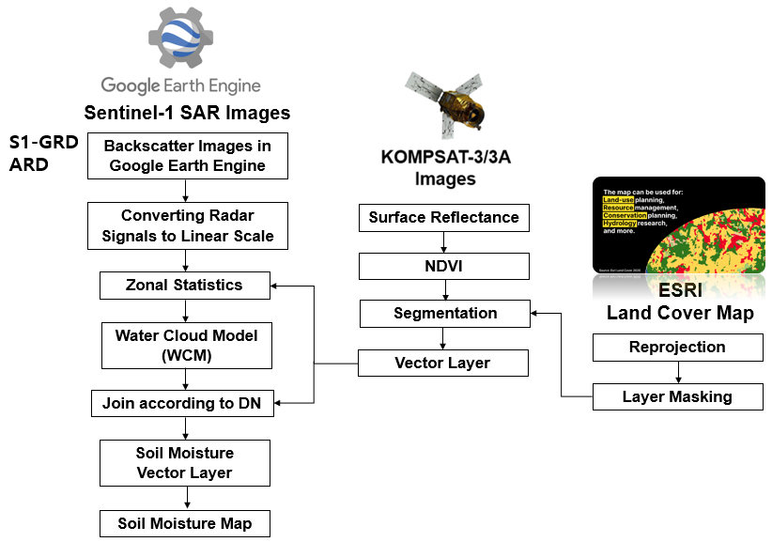

Figure 1. Workflow and data applied in this study.

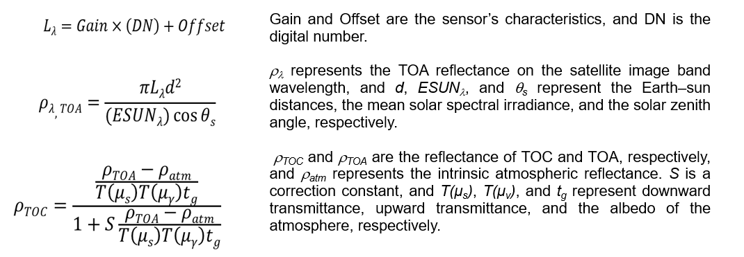

Figure 2. Surface reflectance or TOCR computation algorithm for KOMPSAT-3/3A (Kim and Lee, 2021).

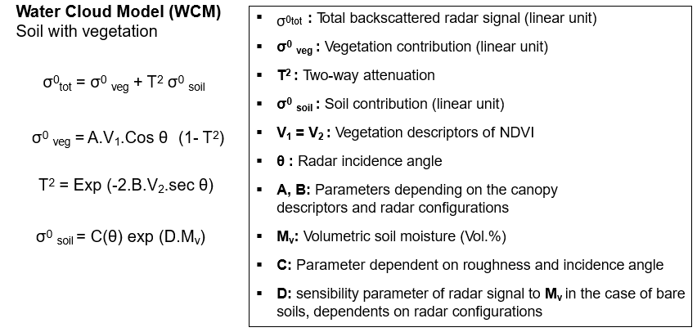

Figure 3. Water cloud model for Sentinel-1 SAR images applied in this study (Baghdadi and Zribi, 2016; Hajj et al. 2017).

Study Area and Applied Data

Summary of the study area

The Gimje Plain is a large plain located in the southwestern part of South Korea. The plain is about 100 km long and 50 km wide, covering an area of about 5,000 km2, as shown in Figure 4. The plain is composed of two types of terrain: a floodplain developed in the Dongjin River and Mankyeong River basins, and an erosion plain centered on a wide area of hills. Most of this plain was originally a floodplain where natural levees and river backwaters developed. The sedimentary layers of this floodplain were formed by the deposition of silt, clay, sand, and mud on bedrock from the mouth of the Mankyeong River. It is low and flat with an elevation of 5-6 meters. The hilly area connected to the floodplain is widely developed around the watersheds of small rivers. It has a very gentle slope with an elevation of about 20 meters. The Gimje Plain is an important agricultural region in South Korea. It is home to a variety of crops and is a major producer of rice. The plain is also an important transportation hub and is well irrigated. The Plain has a humid subtropical climate, which means that it receives a lot of rain and has mild winters. This climate is ideal for growing rice and other crops. The soil in the plain is very fertile due to the deposition of silt and clay by the many large and small rivers. This irrigation is essential for growing crops during the dry summer months. The plain is flat and gently sloping, which makes it easy to cultivate.

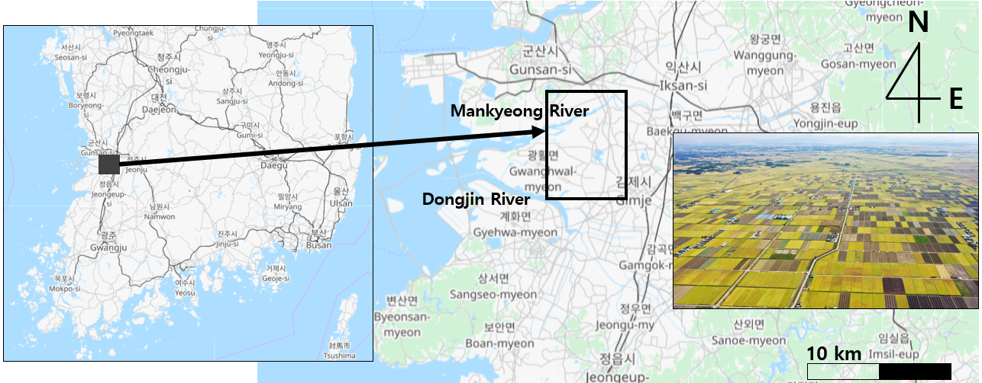

Figure 4. The study area: Gimje Plain.

Applied data and products

Figure 5 shows the applied data and required products for surface soil moisture estimation. Figure 5(a) is the access process of GEE Sentinel-1 SAR ARD through API. Figure 5(b) shows the KOMPSAT-3/3A coverage and its overlap area. KOMPSAT-3 images show some different characteristics with KOMPSAT-3A in terms of orbit, swath and GSD. However, the spectral bands of Pan, R, G, B, and NIR are the same (Table 1). Figure 5(c) is the ESRI land cover map.
Four sets of satellite images are collected to estimate the seasonal change in the study area (Table 2). As for Sentinel-1 SAR backscatter ARD, two types of VV and VH polarization data were used for WCM calculation. Multispectral bands of KOMPSAT-3/3A imagery were used for NDVI computation as shown in Figure 6. While it is desirable to use land cover maps that match the date of satellite image acquisition in research, this study used representative data such as ESRI data because it used land cover maps for the purpose of extracting agricultural areas and major vegetation areas.

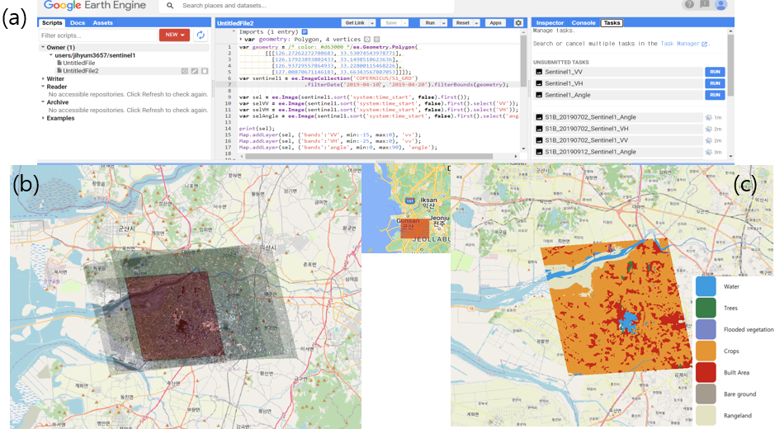

Figure 5. Applied data: (a) GEE Sentinel-1 SAR, (b) KOMPSAT-3/3A coverage, and (c) Land cover map by ESRI.

Table 1. Summary of KOMPSAT-3/3A
Mission characteristics | KOMPSAT-3 | KOMPSAT-3A
Launch time | 18 May 2012 | 26 Mar 2015
Orbit altitude | 685 km | 528 km
Swath width | ≥ 15 km (at nadir) | ≥ 12 km (at nadir)
Ground sample distance (GSD) | Pan: 0.7 m  MS: 2.8 m | Pan: 0.55 m  MS: 2.2 m  IR: 5.5 m
Spectral bands | Pan: 450-900 nm  Blue: 450-520 nm  Green: 520-600 nm  Red: 630-690 nm  NIR: 760-900 nm | Pan: 450-900 nm  Blue: 450-520 nm  Green: 520-600 nm  Red: 630-690 nm  NIR: 760-900 nm  MWIR: 3300-5200 nm
Radiometric resolution | 14 bits | 14 bits

Table 2. Applied data
 | Sentinel-1 SAR | KOMPSAT-3/3A | Land cover map
March 2019 | Sentinel-1B VV, VH (2019-03-28) | KOMPSAT-3A MS  (2019-03-24) | ESRI Land  Cover Map 2019
April 2019 | Sentinel-1A VV, VH  (2019-04-15) | KOMPSAT-3 MS  (2019-04-15)
July 2019 | Sentinel-1A VV, VH  (2019-07-08) | KOMPSAT-3 MS  (2019-07-06)
September 2019 | Sentinel-1B VV, VH  (2019-09-12) | KOMPSAT-3 MS  (2019-09-13)

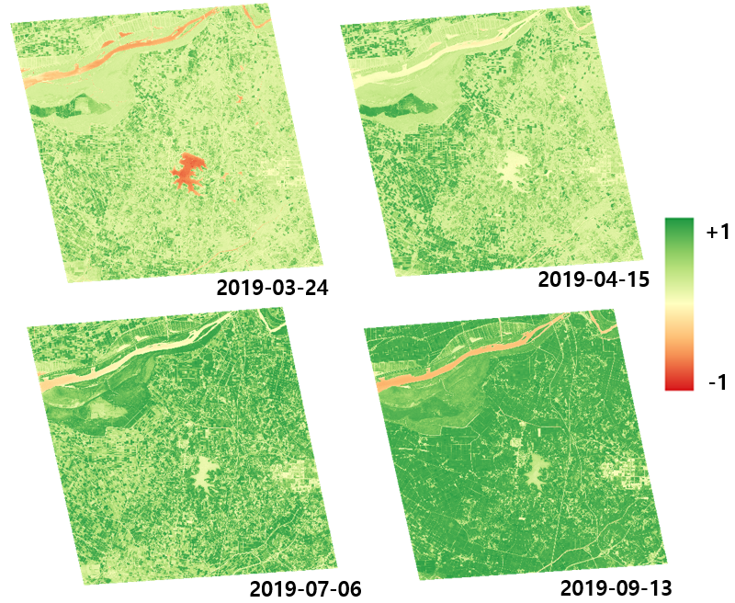

Figure 6. Seasonal change of NDVI by surface reflectance of KOMPSAT-3/3A in the Gimje Plain.

results and discussion
Soil moisture conditions in the Gimje Plain, Korea, vary with the seasons. The wettest season is from June to September, when the plain receives the most rainfall. The driest season is from November to March, when the plain receives the least rainfall. Soil moisture in the Gimje Plain is affected by a number of factors, including rainfall, evaporation, and evapotranspiration. Precipitation is the most important factor, but evaporation and evapotranspiration can also play a role. Evaporation and evapotranspiration are closely related to air temperature, humidity, wind speed, and solar radiation. Soil moisture can vary greatly depending on the season and location. For example, the soil moisture level in the rice fields is usually higher than the soil moisture level in the highlands. The soil moisture level is also affected by the type of soil. Sandy soils tend to have lower soil moisture levels than clay soils. Soil moisture is an important factor for agricultural production in the Gimje Plain. Crops need a certain amount of water to grow. If the soil moisture level is too low, crops can suffer from drought stress. If soil moisture is too high, crops can suffer from waterlogging.
Figure 7 shows monthly average agricultural weather data in 2019 around the Gimje Plain, provided by the Rural Development Administration (RDA) in Korea (https://weather.rda.go.kr/). Figure 8 shows the seasonal change of soil moisture estimated by this study in the Gimje Plain.
There are many meteorological factors that affect surface soil moisture content, but in this study, the average monthly temperature, humidity, and precipitation in 2019 were used as reference data for analyzing the results. Precipitation is the most important factor affecting surface soil moisture. The amount of precipitation that falls on an area determines the amount of water available to the soil. In general, areas with high precipitation will have higher surface soil moisture than areas with low precipitation. The soil moisture map generated in this study shows a high overall content in September. This is because the average rainfall in September is very high. Especially, the precipitation of city near the Gimje Plain on September 12 was recorded over 20 mm according to archived weather data in KMA (Korea Meteorological Administration). This can be interpreted in the same way as the low soil moisture content due to low precipitation in March. The reason for the low soil moisture content in July is that although July is a month with average high rainfall, the dates on which the images used in the study were collected had no rainfall in archived weather data in KMA or surface input, and the rainfall increased from mid-July to the end of the month.
The river estuary, located in the upper right corner of the study area, where the sea and river meet, shows a sharp change in soil moisture content depending on rainfall.

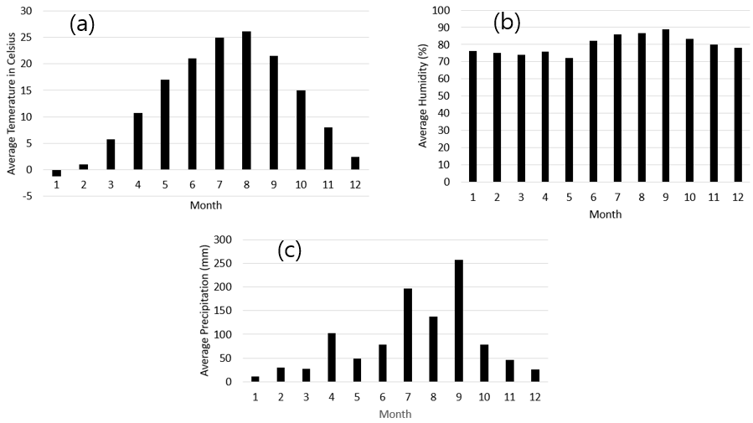

Figure 7. Monthly average agriculture weather data in 2019 around the Gimje Plain: (a) Temperature, (b) Humidity, and (c) Precipitation.

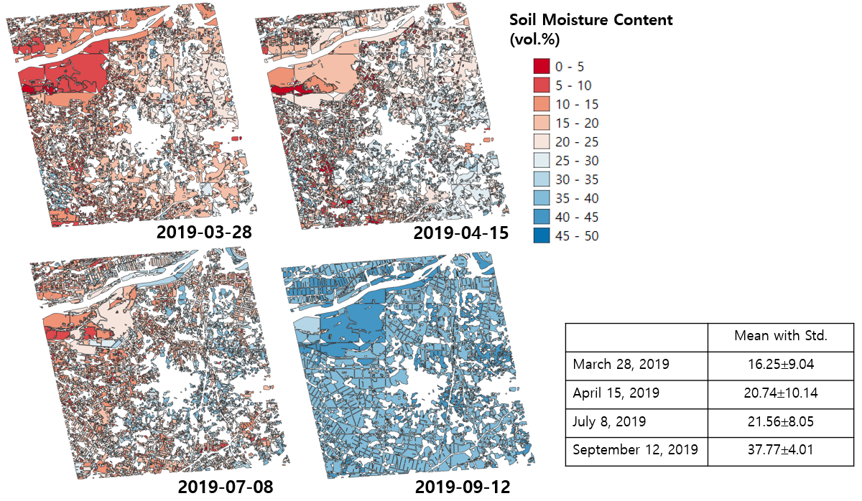

Figure 8. Seasonal change of soil moisture contents estimated by this study in the Gimje Plain.

concluding remarks
The WCM has been shown to be effective for estimating soil moisture from SAR data under a variety of conditions. However, the accuracy of the model can be affected by a number of factors, such as the type of SAR data, soil texture, and vegetation density.
The processing method used in this study has the following major advantages. First, it simultaneously applied high-resolution KOMPSAT images to the process of estimating soil moisture content in an arbitrary region by applying SAR images provided by GEE and land cover maps provided free of charge by ESRI. Of course, if users use Sentinel-2 or Landsat images instead of KOMPSAT-3/3A images, they can create a soil moisture map in any region at no additional cost. Second, the results produced in this study are generated as 2D spatial information, which allows for additional spatial analysis of soil moisture content. This allows for more accurate regional analysis over time than studies that simply compare statistical changes over long-term wide areas. Third, the monthly changes resulting from this study show results that are in good agreement with weather conditions.
This study used C-band satellite imagery as the basic data for estimating soil moisture, so it mainly shows surface moisture within a few centi-meters of the surface. Therefore, it may differ from the values of deep soil moisture content measured in the field. However, we believe that both field measurement data and satellite-based soil moisture content have scientific significance and practical applicability.

Acknowledgements
This work was supported by the National Research Foundation of Korea (NRF) grant funded by the Korea government (MSIT) (No. RS-2023-00241346).

References
Baghdadi, N. and Zribi, M., 2016. Land Surface Remote Sensing in Continental Hydrology, ISTE Press, Oxford, UK
Brocca, L., Tarpanelli, A., Filippucci, P., Dorigo, W., Zaussinger, F., Gruber, A., and Fernández-Prieto, D., 2018. How much water is used for irrigation? A new approach exploiting coarse resolution satellite soil moisture products. International Journal of Applied Earth Observation and Geoinformation, 73, pp. 752-766.
Bousbih, S., Zribi, M., Hajj, M. E., Baghdadi, N., Lili-Chabaane, Z., Gao, Q., and Fanise, P., 2018. Soil Moisture and Irrigation Mapping in A Semi-Arid Region, Based on the Synergetic Use of Sentinel-1 and Sentinel-2 Data. Remote Sensing, 10(12), 1953.
Hajj, M. E., Baghdadi, N., Zribi, M., and Bazzi, H., 2017. Synergic Use of Sentinel-1 and Sentinel-2 Images for Operational Soil Moisture Mapping at High Spatial Resolution over Agricultural Areas. Remote Sensing, 9(12), 1292.
He, W. and Yokoya, N., 2018. Multi-Temporal Sentinel-1 and -2 Data Fusion for Optical Image Simulation. ISPRS International Journal of Geo-Information, 7(10), 389.
Jeong, J., Cho, S., Jeon, H., Lee, S., and Choi, M., 2022. Assessment of the Self-Sufficiency of Sentinel-1 SAR for Machine Learning-Based High-Resolution Soil Moisture Retrieval. Korean Journal of Remote Sensing, 38(5), pp. 571-585.
Kaplan, G. and Avdan, U., 2018. Sentinel-1 and Sentinel-2 data Fusion for Wetlands Mapping: Balikdami, Turkey. In The International Archives of the Photogrammetry, Remote Sensing and Spatial Information Sciences, Volume XLII-3, 2018, ISPRS TC III Mid-term Symposium “Developments, Technologies and Applications in Remote Sensing”, 7–10 May, Beijing, China.
Kim, K. and K. Lee, 2021. An Implementation of Open Source-Based Software as a Service (SaaS) to Produce TOA and TOC Reflectance of High-Resolution KOMPSAT-3/3A Satellite Image, Remote Sensing, 13(22), 4550.
Lee, J., Kim, K., and Lee, K., 2022. Comparative Analysis of NDWI and Soil Moisture Map Using Sentinel-1 SAR and KOMPSAT-3 Images. Korean Journal of Remote Sensing, 38(6-4), pp. 1935~1943. (in Korean)
Lee, T., Kim, S., Lee, S.-H., Choi, K.-S., Shin, Y., Lim, K., and Park, Y., 2018. Development of Soil Moisture Data Assimilation Scheme for Predicting Effective Soil Characteristics Using Remotely Sensed Data. Journal of the Korean Society of Agricultural Engineers, 60(1), pp. 21~30. (in Korean)
Manakos, I., Kordelas, G. A., and Marini, K., 2020. Fusion of Sentinel-1 data with Sentinel-2 products to overcome non-favourable atmospheric conditions for the delineation of inundation maps. European Journal of Remote Sensing, 53(sup2), pp. 53-66.
Mardan, M. and Ahmadi, S., 2021. Soil moisture retrieval over agricultural fields through integration of synthetic aperture radar and optical images. GISCIENCE & REMOTE SENSING, 58(8), pp. 1276–1299.
Mullissa, A., Vollrath, A., Odongo-Braun, C., Slagter, B., Balling, J., Gou, Y., Gorelick, N., and Reiche, J., 2021. Sentinel-1 SAR Backscatter Analysis Ready Data Preparation in Google Earth Engine. Remote Sensing, 13, 1954.
Jiang, Q., Tang, Z., Zhou, L., Hu, G., Deng, G., Xu, M., and Sang, G., 2023. Mapping Paddy Rice Planting Area in Dongting Lake Area Combining Time Series Sentinel-1 and Sentinel-2 Images. Remote Sensing, 15(1), 2794.
Robock, A., Vinnikov, K. Y., Srinivasan, G., Entin, J. K., Hollinger, S. E., Speranskaya, N. A., and Namkhai, A., 2000. The global soil moisture data bank. Bulletin of the American Meteorological Society, 81(6), pp. 1281-1300.
Seneviratne, S. I., Corti, T., Davin, E. L., Hirschi, M., Jaeger, E. B., Lehner, I., and Teuling, A. J., 2010. Investigating soil moisture–climate interactions in a changing climate: A review. Earth-Science Reviews, 99(3-4), pp. 125-161.
Tao, L., Ryu, D., Western, A., and Lee, S. G., 2022. Comparison of KOMPSAT-5 and Sentinel-1 Radar Data for Soil Moisture Estimations Using a New Semi-Empirical Model. Remote Sensing, 14(16), 4042.
Ochsner, T. E., Cosh, M. H., Cuenca, R. H., Dorigo, W. A., Draper, C. S., Hagimoto, Y., and Zreda, M., 2013. State of the art in large‐scale soil moisture monitoring. Soil Science Society of America Journal, 77(6), pp. 1888-1919.
Venter, Z. S., Barton, D. N., Chakraborty, T., Simensen, T., and Singh, G., 2022. Global 10 m Land Use Land Cover Datasets: A Comparison of Dynamic World, World Cover and ESRI Land Cover. Remote Sensing, 14(16), 4101.

